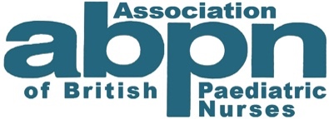
Call for nominations for ABPN Honorary Fellowships

Following the award of Honorary Fellows at our last Annual General Meeting, the Association is seeking nominations for individuals to be awarded Honorary Fellowship of the ABPN in 2024.
Who can be nominated?
There are two categories of Honorary Fellow:
- Individuals from the UK and elsewhere, who are not members of the ABPN can be nominated in recognition of their experience, achievements, dedication, and outstanding contributions to the care of children and young people. This can reflect contributions through practice, leadership, education, research and other areas.
- Individuals, who are members of the ABPN, can be nominated to reflect their long and valuable service to the Association.
How to nominate
- Please do not tell the person you have nominated them.
- Please complete the nomination form and submit it to our Honorary Secretary, Robin Hyde robin.hyde@northumbria.ac.uk
- Receipt of your nomination will be confirmed.
Timeline
Nominations due by | 30th September 2023
Nominations Committee make recommendations by | 30th November 2023
Governance and Development Board recommendation by | 15th December 2023
Nominees offered award of Honorary Fellowship by | 20th December 2023
Nominees accept award by | 23rd January 2024
Notice of nominees’ acceptance to G&D Board by | 16th February 2024
Final approval by at Annual General Meeting on | 26th or 27th March 2024
Announcement and celebration of Fellows by | 12th April 2024

